**Hotel Management System**

* **Group member:**
* Amr Fathy
  + - * Mohamed Mahmod
        + Nada Saeed

Yara Hatem

**Hotel Management System**

Description:  
The Hotel Management System provides a comprehensive solution for seamless hotel operations. It efficiently manages guest reservations, room allocations, and staff assignments. The system facilitates streamlined check-in/check-out processes, tracks room availability, and ensures precise billing through integrated payment and feedback modules. Offering centralized control over services, staff, and guest interactions, it enhances overall guest satisfaction. The system's robust architecture makes it adaptable to diverse hotel sizes and types, promoting operational efficiency, accuracy, and customer service excellence. Whether a boutique hotel or a large-scale resort, the Hotel Management System optimizes administrative tasks, enhances guest experiences, and contributes to the overall success of the hospitality business.

**Entities of Hotel Management System:**

**Hotel: (**Hotel ID **(PK)** - Name - Location - Rating - Facilities**)**

**Guest: (**Guest ID **(PK)** - FirstName - LastName - Nationality - Date of Birth - Address - Email - Phone - Hotel ID **(FK)** - Feedback ID **(FK))**

**Reservation: (**Reservation ID **(PK)** - Guest ID - Room Number - Check in Date - Check out Date - Number of Guests - Reservation Date - Payment ID **(FK)** - Receptionist ID **(FK))**

**Room: (**Room Number **(PK)** - Room Type - Room Rate - Bed Type - Room category - Room view - Location - Availability - Description- Reservation ID **(FK))**

**Receptionist: (**Receptionist ID **(PK)** - First Name - Last Name - Date of Birth - Position - Salary - Hire Date- Hotel ID **(FK))**

**Service: (**Service ID **(PK)** - Service Name - Service Type - Description - Cost- Hotel ID **(FK))**

**Payment: (**Payment ID **(PK)** - Reservation ID - Payment Date - Cash - Payment Method**)**

**Staff: (**Staff ID **(PK)** - Hotel ID **(FK)** - Staff category - Name - Position - Contact Info**)**

**Feedback: (**Feedback ID **(PK)** - Guest ID - Reservation ID - Rating – Comments**)**

**Guest-Reservation: (**Guest ID **(PK) (FK)** - Reservation ID **(PK) (FK)** - Reservation Date**)**

**The Relations of The Entities:**

* Hotel receives Guest (One-to-Many)
* Hotel provides Service (One-to-Many)
* Hotel employs Staff (One-to-Many)
* Guest gives Feedback (One-to-Many)
* Guest makes Reservation (One-to-Many)
* Reservation confirmed by Receptionist (Many-to-One)
* Reservation approves Payment (One-to-One)
* Reservation checks Room (One-to-Many)

**The Entities Relations Diagram (ERD):**

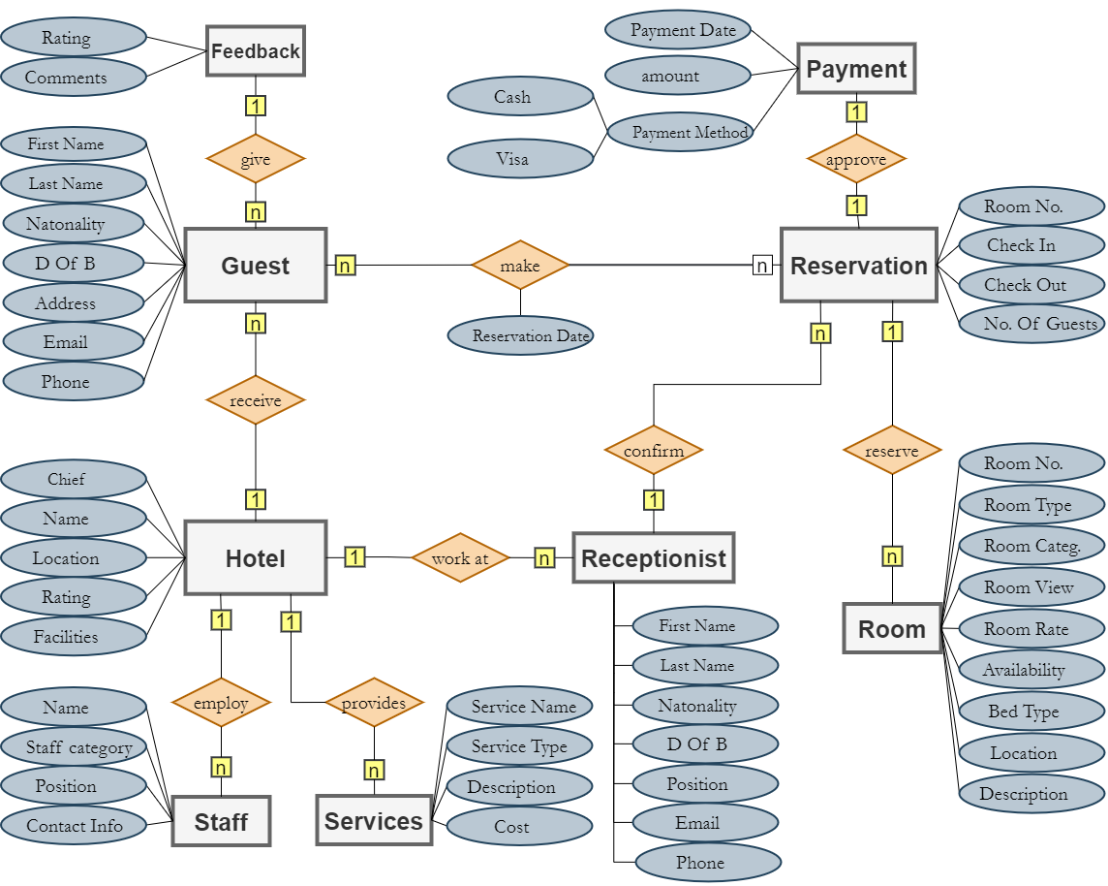

**Mapping:**

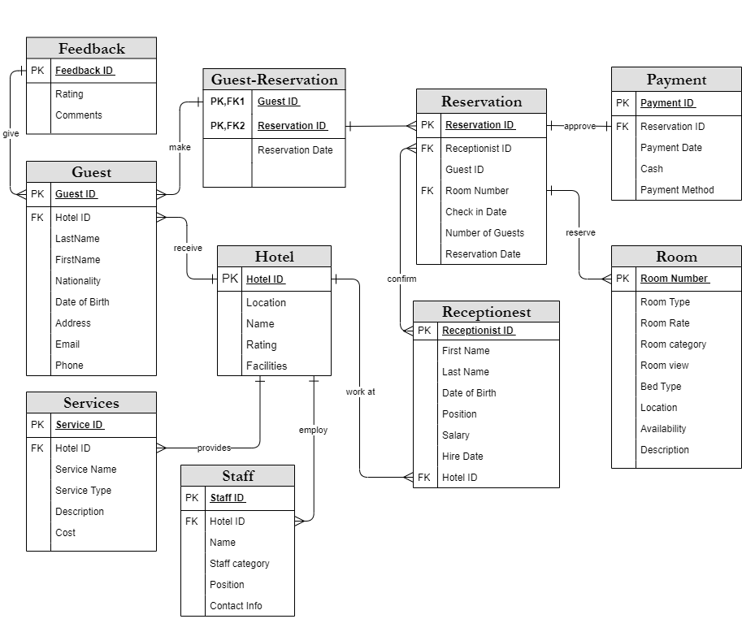

**reports:**

* Retrieves guest comments and ratings for a specified hotel.

CREATE PROCEDURE GetGuestCommentsByHotel @HotelName VARCHAR(255)

AS BEGIN   
SELECT Hotel.Name as HotelName, Guest.FirstName, Guest.LastName, Feedback.Rate, Feedback.Comments

        FROM Hotel

        JOIN Guest ON Guest.HotelID = Hotel.HotelID

        JOIN Feedback ON Guest.FeedbackID = Feedback.FeedbackID

            WHERE Hotel.Name = @HotelName;

    END;

EXEC GetGuestCommentsByHotel @HotelName = 'Nile Plaza Hotel';

EXEC GetGuestCommentsByHotel @HotelName = 'Pyramids View Resort';

EXEC GetGuestCommentsByHotel @HotelName = 'Red Sea Oasis Hotel';

EXEC GetGuestCommentsByHotel @HotelName = 'Luxor Palace Hotel';

* EXEC GetGuestCommentsByHotel @HotelName = 'Alexandria Beach Resort';
* results

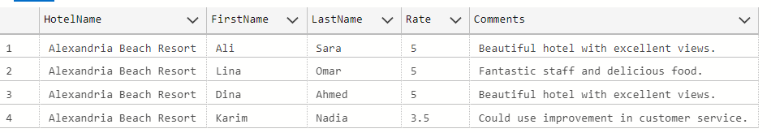

* List of Services and their Cost per hotel.

SELECT  h.Name as HotelName,s.ServiceName, s.ServiceType, s.Description, s.Cost

FROM Service s

JOIN Hotel h ON s.HotelID = h.HotelID

WHERE h.Name = 'Nile Plaza Hotel';

* results

* List of Available Rooms.

SELECT RoomNumber, RoomType, RoomRate, BedType, RoomCategory, RoomView, Branch, Description

FROM Room

WHERE Availability = 1;

* results

* Guest Staying duration, rate, Billing Report.

SELECT

    Guest.FirstName,

    Guest.LastName,

    Reservation.NumberOfGuests,

    Reservation.RoomNumber,

    Room.RoomType,

    Room.RoomRate,

    DATEDIFF(DAY, Reservation.CheckInDate, Reservation.CheckOutDate) AS StayDuration,

    (DATEDIFF(DAY, Reservation.CheckInDate, Reservation.CheckOutDate) * Room.RoomRate) AS TotalRate

FROM Guest

JOIN Reservation ON Guest.GuestID = Reservation.GuestID

JOIN Room ON Reservation.RoomNumber = Room.RoomNumber;

* Results

* Guests and Reservation Count

SELECT

    g.FirstName,

    g.LastName,

    COUNT(r.ReservationID) AS ReservationCount

FROM Guest g

    LEFT JOIN Reservation r ON g.GuestID = r.GuestID

GROUP BY g.GuestID, g.FirstName, g.LastName;

* Results

* Services Usage and Cost by Hotel.

SELECT s.ServiceName, s.Cost, h.Name AS HotelName,

    COUNT(*) AS ServiceUsage

FROM Service s LEFT JOIN Hotel h ON s.HotelID = h.HotelID

GROUP BY s.ServiceName, s.Cost, h.Name

ORDER BY s.Cost ASC;

* Results

* -- Average of guest Rating by Hotel

SELECT

h.Name AS HotelName, h.Rating, AVG(f.Rate) AS AverageRatingbyguest

FROM Hotel h

    JOIN Guest g ON h.HotelID = g.HotelID

    JOIN Feedback f ON g.FeedbackID = f.FeedbackID

GROUP BY h.HotelID, h.Name, h.Rating

ORDER BY AverageRatingbyguest DESC;

* Results

* Reservation Details.

SELECT r.ReservationID, g.FirstName, g.LastName, r.CheckInDate, r.CheckOutDate

FROM Reservation r

    JOIN Guest g ON r.GuestID = g.GuestID;

* Results

**Dashboard**

